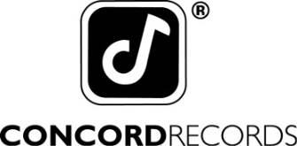

DEVOTCHKA ANNOUNCE NEW ALBUM
THIS NIGHT FALLS FOREVER
AVAILABLE AUGUST 24

SHARE NEW SONG “STRAIGHT SHOT”

NEW FALL TOUR DATES

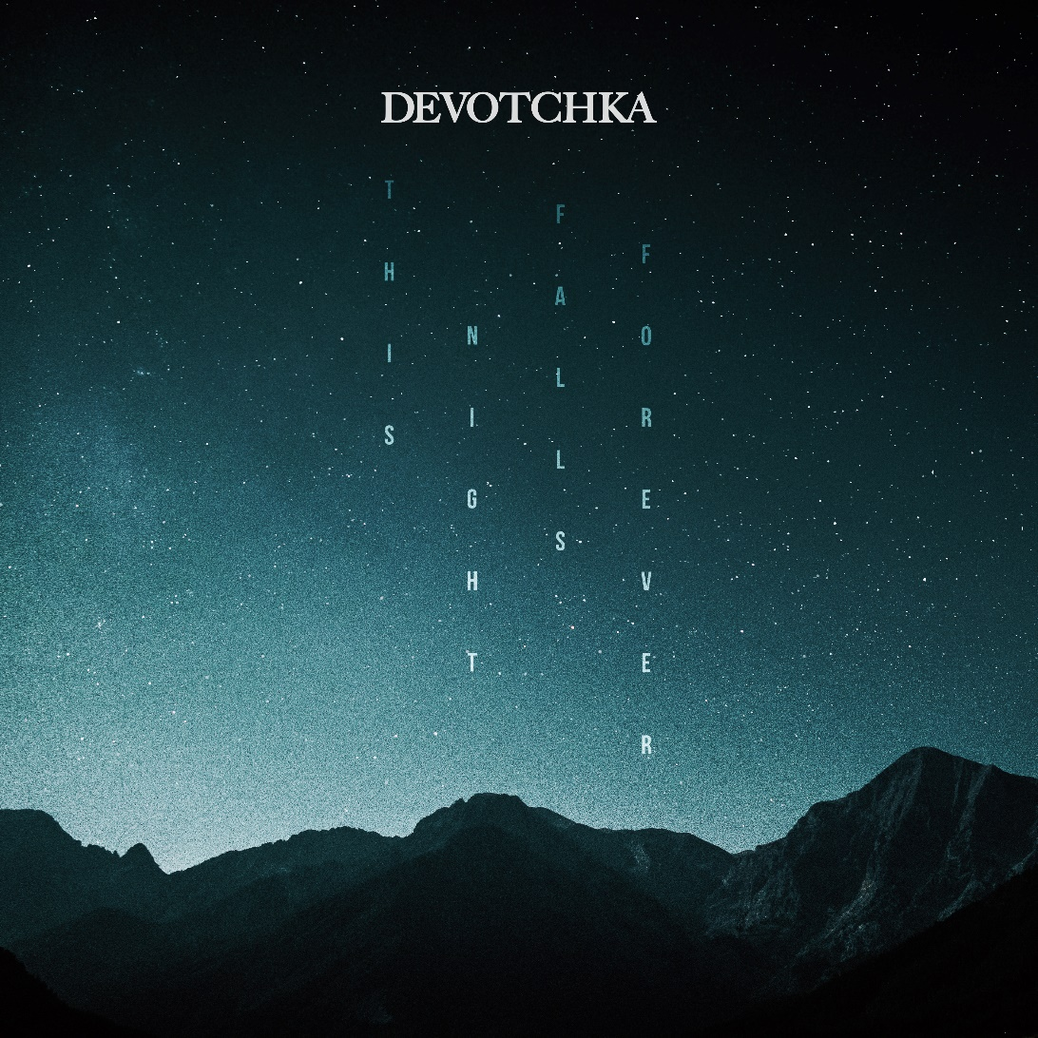

WATCH THE LYRIC VIDEO FOR “STRAIGHT SHOT” HERE:
http://found.ee/DeVotchKa_StraightShotYT

July 13, 2018 – The genre-defying ensemble Devotchka announce their return today with the new song “Straight Shot” from This Night Falls Forever, their August 24 album release on Concord Records. In addition, they share a string of tour dates for the fall season throughout the U.S. and Europe.

“Straight Shot” is the first track on the new album; a rhythmic and urgent opener for the group’s resurgence. “This song is like a moonlit swim through heartbreak, in a sea of ghosts from your past,” Devotchka frontman Nick Urata says. “When you realize the old neighborhood may be gone forever, but you can carry it with you through the darkest of days.”

After scoring films, TV, musicals, ballets, and performing with symphony orchestras,
Devotchka emerge from the studio with their sixth full-length album, featuring 11 songs that defy categorization. These songs straddle the line between the epic and the intimate. Devotchka have garnered much praise and attention for blurring the lines of genre and cultural influence, and with this release we can clearly see they have slowly carved their own unique space in the modern musical landscape. Urata’s soaring vocal croon and poetic lyrics are back in full force. His voice travels atop ambitious film noir orchestras and live vintage voodoo rock combos.

This Night Falls Forever is scheduled for release on August 24, 2018 via Concord Records. Available on vinyl, CD and digital. Pre-order for This Night Falls Forever begins today, July 13, 2018, via http://found.ee/DeVotchKa_ThisNightFallsForever. Additional tour details will be announced on July 18, 2018.

TOUR DATES:

August 23 – New York, NY

September 19 - Vancouver, BC

September 20 - Seattle, WA
September 21 - Portland, OR
September 24 - San Francisco, CA
September 25 - Santa Cruz, CA
September 27 - Anaheim, CA
September 28 - San Diego, CA

September 29 - Los Angeles, CA
September 30 - Phoenix, AZ
October 02 - Santa Fe, NM
October 04 - Chicago, IL
October 05 - St. Louis, MO
October 06 - Kansas City, MO
October 07 - Minneapolis, MN
November 27 – December 01 - Europe

CONNECT:

Official Website: devotchka.net

Facebook: @devotchkamusic

Twitter: @devotchkamusic

Instagram: @devotchkamusic
YouTube: @devotchka

Online media kit: http://mediakits.concordmusicgroup.com/p/this-night-falls-forever

CONTACTS:
Jim Merlis/Big Hassle Media: jim@bighassle.com

Mike Wilpizeski/Concord Records: mike.wilpizeski@concordrecords.com

