RC_2C_neutral_hiCONCORD RECORDS

**FOR IMMEDIATE RELEASE**

*"Emily Bear blew me away - I mean she's really, really phenomenal"* - **Ellen DeGeneres**

**11-YEAR-OLD MUSICAL PRODIGY EMILY BEAR, SET TO RELEASE CONCORD RECORDS/QWEST RECORDS DEBUT *DIVERSITY* ON MAY 7*,* PRODUCED BY MENTOR QUINCY JONES**

***DIVERSITY* FEATURES 13-ORIGINAL SONGS WRITTEN BY THE YOUNG PIANIST/COMPOSER IN A "DIVERSE" COLLECTION OF STYLES**

*Record Release Parties & Press Dates Scheduled in*

*New York (5/15) and Los Angeles (5/8)*

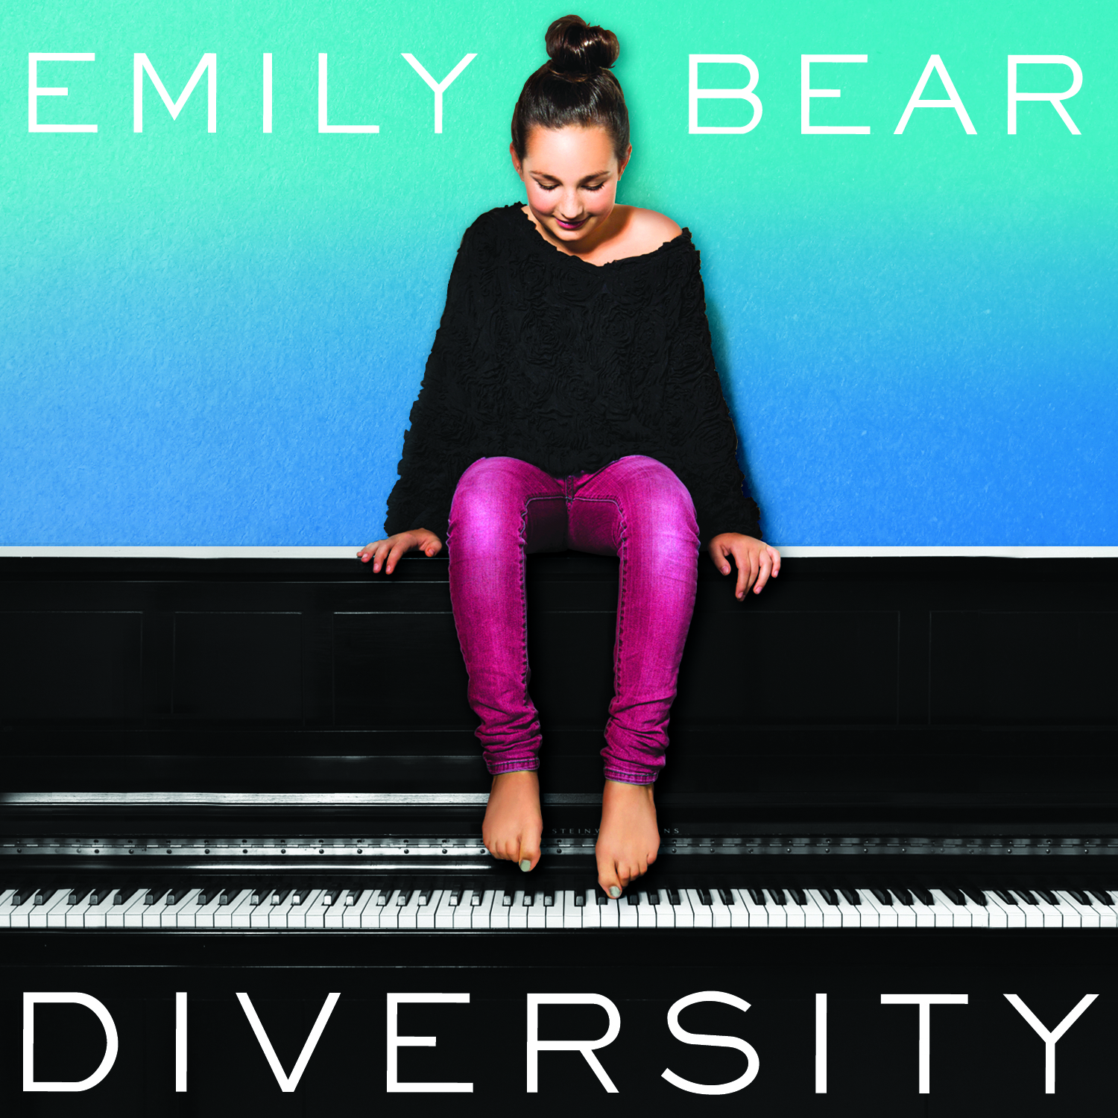

(**Los Angeles, CA**) -- 11-year-old musical prodigy **Emily Bear,** a pianist and composer set to release **Concord Records/Qwest Records** debut ***Diversity*** on **May 7**, produced by legendary multi-Grammy Award winning producer, composer and arranger **Quincy Jones**. **Bear**, who is managed by Quincy Jones Productions, has the ability to seamlessly move from *Classical* to *Jazz* and *Be-bop*, while demonstrating musical prowess comparable to pianists/composers twice her age, has written 13-original songs for the new project***,*** performed with a Jazz Trio. She first broke into the national spotlight at **age 6**, as a guest on the **Ellen DeGeneres Show**,performing *Mozart*, jazz and an original song she composed. She was invited back five more times within the span of two years, performing original music each visit.

Comments **Quincy Jones**: *“I am at once astounded and inspired by the enormous talent that Emily embodies. She is the complete 360-degree package, and there are no limits to the musical heights that she can reach.”*

**Jones** will join **Bear** for record release parties in **NY** (5/15) and **LA** (5/8), which also includes scheduled press dates.

*“Emily is extraordinarily gifted,”*says **John** **Burk**, Chief Creative Officer, Concord Music Group. *“She obviously has incredibly advanced technical skills far beyond her years, but what I find most extraordinary, is her emotional and compositional depth.”*

The CD title ***Diversity*** represents the diversity of **Bear's** style, as well as the diversity of the cultures that are her musical influences. The project was recorded at **Westlake Studios.** Using **Bear's** own jazz trio handpicked by **Jones**, she demonstrates both her versatility and an open-hearted melodic soul at the piano, composing, orchestrating and performing a multi-genre repertoire with full command.

Some of her reflective mood compositions include **“Blue Note,”** **“Alika,” “Jessie’s Song”** and **“Tutti Cuore”;** While she gets down with a *Latin feeling* in the rhythm section with the catchy **“Hot Peppers”** and self-explanatory **“Salsa Americana”**.  **“Peralada”** conveys a specific *Spanish flavor*, as inspired by the Catalan city where she first performed this piece at a music festival, and she utilizes her classical technique to a tee in **“Reflections.”**  **“Northern Lights”** is the piece for which she won an **ASCAP Morton Gould Young Composer Award** at the tender age of 6, and **“Q”** refers to the nickname of **Bear's** legendary producer, which after a heartfelt slow intro, turns into a jaunty jazz-trio tribute to the ever-youthful spirit of the iconic music figure.

**Bear,** who plays all of her music from memory, including 45-page classical concertos, started to show extraordinary musical talent practically from the cradle. As a baby, she would sing back lullabies to her mother in perfect pitch. By 18 months, she was experimenting constantly at the piano. She was composing tangible pieces at age 3. By the time **Bear** was 4, she was having pieces published and distributed by Hal Leonard.

She made her concert debut at the **Ravinia Festival** in **Chicago** at **age 5**, playing a 40-minute solo program performing classical pieces side-by-side with jazz numbers, and her own compositions. She was invited to perform at the **White House** at **age 6**, and opened for the **Ramsey Lewis Trio** with a 30-minute set of her own. Her orchestral debut came at **age 7**, playing *Mozart Piano Concerto no. 23, K488* and by **age 8**, she was playing concerts abroad in Italy and China. At **age 9**, she made her **Carnegie Hall** debut with a 110-piece orchestra, a 220-voice choir, and R&B soloists performing one of her compositions, *“Peace – We Are The Future.”*

In 2011, **Bear** had yet another big year when she made her debut at the **Hollywood Bowl**, performing a medley of her own compositions with singers *Gloria Estefan, Patti Austin, Siedah Garrett* and *Nikki Yanofsky.*  That summer, **Jones** also presented her at the **45th Montreux Jazz Festival** and the **Festival Castell** in Peralada, Spain.

**Bear** has since been featured on several major news programs, including *Good Morning America, ABC World News Report with Diane Sawyer, ABC Nightline, and the Katie Couric Show*. Internationally, she has been featured in stories on Swiss, German, Australian, Italian and Chinese television.

*“I’m a regular kid who was lucky enough to find something I really love to do at a very young age,”* says **Bear**. *“Concord has a lot of musicians I look up to so I’m really excited about the opportunity and look forward to sharing my music.”*

Concord Records is a division of Concord Music Group. Concord Music Group’s legendary family of labels includes Concord Records, Concord Jazz, Fantasy, Stax, Milestone, Riverside, Specialty, Telarc, Peak, Heads Up, Prestige and Rounder Records.

For more info on Emily Bear, please visit online press kit:

<http://mediakits.concordmusicgroup.com/p/diversity>

**Contact:**

Leah Price (Concord)

310/385-4234

[leah.price@concordmusicgroup.com](mailto:leah.price@concordmusicgroup.com)

Karen Sundell                                     Lori Lousararian   (Rogers & Cowan)

310/854-8167                                                     310/854-8104

[ksundell@rogersandcowan.com](mailto:ksundell@rogersandcowan.com)                        [llousararian@rogersandcowan.com](mailto:llousararian@rogersandcowan.com)