FOR IMMEDIATE RELEASE JUNE 2015

WIDESPREAD PANIC TO RELEASE THEIR 12th STUDIO ALBUM
STREET DOGS ON SEPTEMBER 25TH ON VANGUARD RECORDS

LONG AWAITED FIRST ALBUM IN FIVE YEARS RECORDED
LIVE IN THE STUDIO A FIRST IN A 30 YEAR CAREER

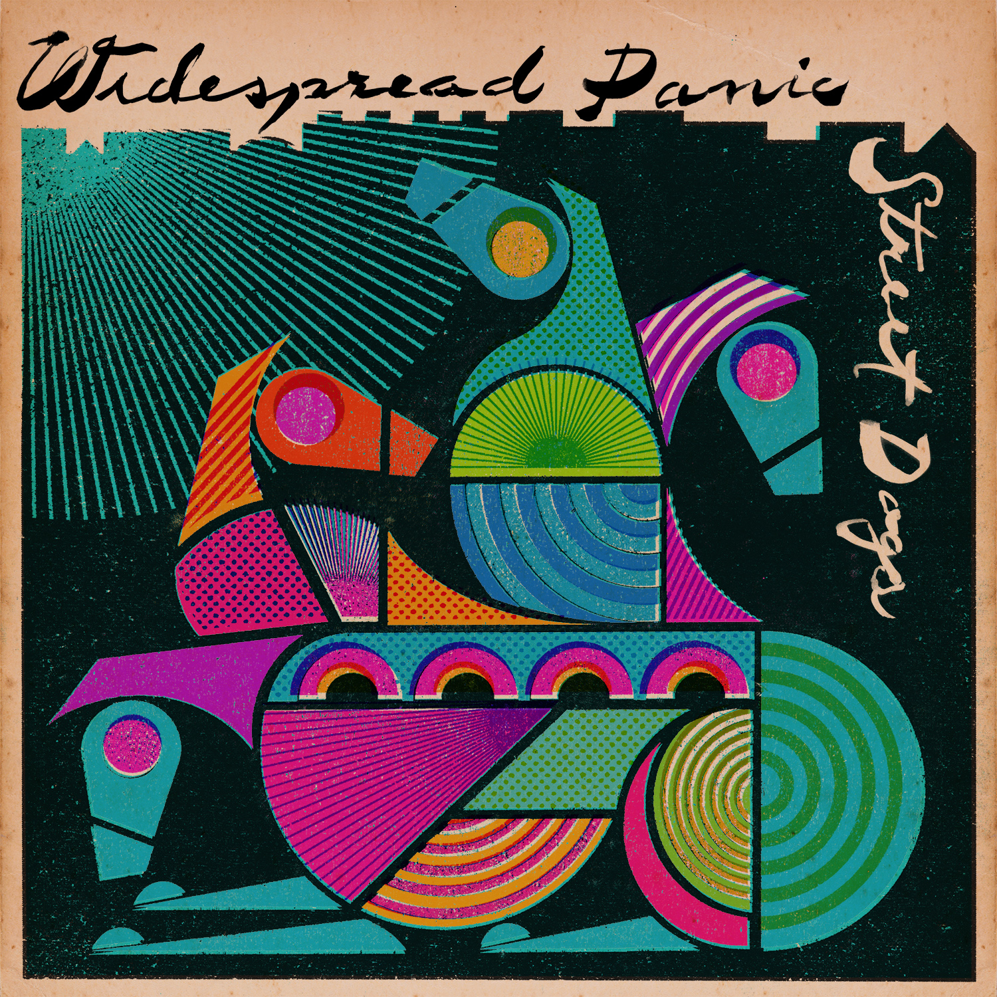

Nashville, TN – Seminal band Widespread Panic has announced the September 25th release of Street Dogs, their long-awaited twelfth studio album on Vanguard Records. Panic recorded Street Dogs as a band, live in the studio, for the first time. The result is the most fun the veteran sextet has had making an album, which is apparent upon first listen. Widespread Panic’s large and loyal legions of fans have waited five years, since the release of 2010’s critically acclaimed Dirty Side Down, for a new offering from the group, and the 10 tracks on Street Dogs are sure to reward their patience, and likely turn on a few more.

For almost 30 years, Widespread Panic has been known for their masterful improvisational style, but their core has always been built around songwriting. Incorporating a vast range of styles, Panic’s songs run the gamut from compelling narratives to poignant ballads to southern blues to progressive jazz and rock. Street Dogs is a testament to how a veteran band can remain vibrant, relevant and continue to progress. The folk/jazz infused “Angels Don’t Sing The Blues”, the flowing “Poorhouse of Positive Thinking”, the boogie blues of “Street Dogs for Breakfast” and the epic New Orleans inspired “Cease Fire”, with it’s Radiohead-like interlude, have a swing and a swagger the runs through much of the album. Panic’s rock and blues roots shine brightly on renditions Alan Price’s “Sell Sell”, Murray McLauchlan’s “Honky Red” and Willie Dixon’s “Taildragger”, made famous by Howlin’ Wolf.

Street Dogs was recorded at Echo Mountain Studios in Asheville, NC with long time friend and producer John Keane at the helm. Drummer Duane Trucks (Hard Working Americans), who has been performing with the band on the road since late-2014, sat in for the Street Dogs recordings.

Widespread Panic’s music and live shows have become a rite of passage for multiple generations who continue to pack venues and follow the band throughout the U.S. Street Dogs is a clear indication that this group will continue to push the creative envelope and is no where near slowing down.

See upcoming tour dates below

For information about Widespread Panic, please contact Jim Flammia
at All Eyes Media (615)-227-2770, jim@alleyesmedia.com or Lucy Sabini at Vanguard Records, Lucy.sabini@concordmusicgroup.com (310) 385-4321

Widespread Panic 2015 Summer Tour Dates

June 23 – Lincoln, NE – Pinewood Bowl Theater
June 24 – Kansas City, MO – Starlight Amphitheater **
June 26-28 – Morrison, CO – Red Rocks Amphitheatre – SOLD OUT
July 2-4 – San Antonio, TX – Majestic Theatre
July 8 – Dallas, TX – Winspear Opera House
July 10 – Albuquerque, NM – Sandia Casino
July 11-12 – Telluride, CO – Ride Festival
July 15 – Oklahoma City, OK – The Zoo Amphitheatre
July 17 – Rogers, AR – Arkansas Music Pavilion
July 18 – Southaven, MS – Snowden Grove Amphitheater
July 19 – Louisville, KY – Forecastle Festival
September 4 – Chicago, IL – North Coast Music Festival
September 5-6 – Nashville, TN – Ascend Amphitheater
September 12-13 – Arrington, VA – Lockn’ Music Festival

** = With special guest Yonder Mountain String Band

