Sierra Hull Announces January Release of
Long-Anticipated Album, Weighted Mind

Bela Fleck-Produced Outing Features Guest Appearances by
Rhiannon Giddens, Alison Krauss, and Abigail Washburn

Hull To Perform on A Prairie Home Companion Saturday, September 26

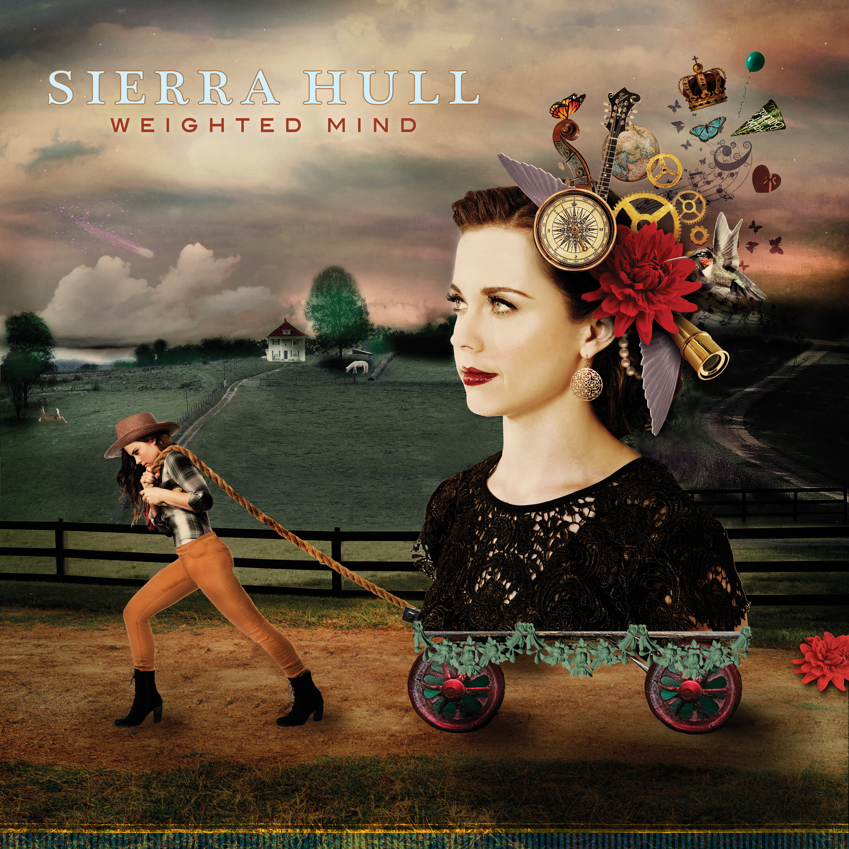

September 25, 2015 – Nashville, TN – Sierra Hull, the singer and mandolinist and former child prodigy who signed with Rounder at age 13, and distinguished herself by becoming the first bluegrass musician to receive a Presidential Scholarship to the prestigious Berklee College of Music, has announced the release of her first new album in five years. Weighted Mind will be released on January 29, 2016.

15-time Grammy winner Béla Fleck produced the recording, which features eleven compelling new compositions written or co-written by Hull, and one traditional tune for which she and Fleck provided a new arrangement. While Hull’s ethereal voice and fluid playing take center stage here, she receives ample support from bass marvel Ethan Jodziewicz. Béla Fleck’s banjo adorns the elegant “Queen of Hearts/Royal Tea,” and Alison Krauss, Abigail Washburn, and Rhiannon Giddens add enchanting harmonies.

Though she is best known for her work as a mandolin player, on these songs, Hull reveals her abundant gifts as a composer and lyricist. Themes of loss and restoration run through the album, starting with the muscular opening number, “Stranded,” and continue on the stirring “Compass,” on which she declares, “I’ve thrown away my compass, done with the chart...I’ll just step out, throw my doubt into the sea, for what’s meant to be will be.” The gentle, dissonant title track ponders existential questions, while the haunting “Birthday” and “Fallen Man” offer somber reflections on strained relationships and impossible choices. The album closes on an optimistic note, with the sweetly assertive “I’ll Be Fine,” and the uplifting, philosophical closer, “Black River.” Fleck, Giddens, Krauss, and Washburn all guest on this track, on which Hull reflects, “A thousand years is but a day, and maybe in a thousand years, I’ll find my way.”

Veteran music scribe and fellow musician Peter Cooper writes, “Hull’s bluegrass roots inform and inspire this soundscape, but bluegrass does not define or limit Weighted Mind. This is not bluegrass music, or chamber music, or pop music. This is original music, from a virtuoso who tells the truth and speaks from herself.”

Hull has earned the admiration of her peers and the press alike: The Bluegrass Situation dubbed her a “mandolin-playing wonder,” and Music City Roots praised her “uncommon maturity—musical and personal,” and noted “one might say she embodies the perfect balance of humility and capability.” The New York Times lauded her as a “prodigious talent,” and for 8 consecutive years, the International Bluegrass Music Association has nominated her for Best Mandolin Player. Her friend and mentor Alison Krauss proclaimed, “Sierra is a remarkably talented, beautiful human being. Success could not come to a more worthy person.” Béla Fleck concurs: “Sierra and Ethan proved themselves to be powerful artists, with extremely high standards. I am so glad to have ended up being a part of this project.”

This Saturday, September 26, Hull will perform a few songs from Weighted Mind on Garrison Keillor’s wildly popular radio program, A Prairie Home Companion. The show, which airs on nearly 700 public radio stations across the country, is also available as a podcast. For station information, go to www.prairiehome.org.

On the following Saturday, October 3, at 9:30 PM, she will appear at the Wide Open Bluegrass Festival in Raleigh, NC, which is presented by the IBMA.

Sierra Hull will tour extensively in 2016, kicking off with a CD release show at Nashville’s City Winery on January 28th. More tour dates will be announced soon.

The album will be available soon for pre-order at www.sierrahull.com.

For more information, please contact Regina Joskow at Rounder: rjoskow@rounder.com, 917-532-5687.

Online media kit: http://mediakits.concordmusicgroup.com/p/weighted-mind/

