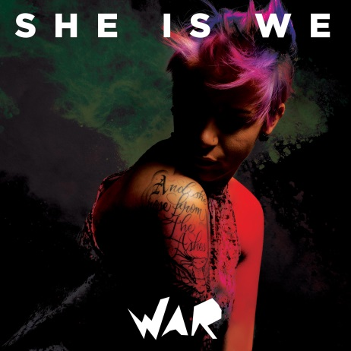

“We are broken hearts with a motive to move the world/doesn’t matter your past my boys and girls/with our stories held tight in our hands/lead the fight” - WAR

When HE IS WE dissolved, Rachel Taylor’s passion and talent didn’t. Her desire to come back stronger drove her, as did the thought of not being able to be there for her fans. Rachel regrouped, drawing strength from her online family. Never one to back down, Rachel is finally seeing her dream come to fruition with the release of WAR, as the artist SHE IS WE, coming out in March, 2016.

“The transition was on my heart. I had realized that I had heard the story of others, but failed to share mine. I was called to lead and bring myself amongst the people who make my job so rewarding. "She" represents my move toward exposing all of my demons in hopes of creating the community of "We", the ones who find one another through music. It's time for all of the He Is We fans to truly meet me through SHE IS WE. “

Rachel has climbed the proverbial mountains, fought the good fight, and kept her head above water so she could share what’s in her heart with the fans that have now become family. “Each and every one of us is fighting a battle, and it’s personal. Whether you’re for or against me, you’re alongside me. So on this album, each track is a separate war, a separate battle, and I am here to share.” Rachel continues, “It was very emotional for me to record this album. I was spiraling toward rock bottom but I would not – I could not – let this group of people that had lived in my heart for years, down. “

WAR [produced by David Hodges, Steve Miller and Taylor] is also her first release for Vanguard Records, a place she feels very comfortable. “With Vanguard, there is more focus on my creative concept and me as an artist. If I don’t feel okay with something, there’s no one there pushing me to do it anyway.”

Rachel likens the songs on WAR to the chapters of a book. “When people listen to this album, they’re listening to the most intimate parts of my mind and my heart. I couldn’t share the secrets that these lyrics hold with anyone other than a piece of paper and a microphone. Here it is, my entire life, poured out on this album. I’ve been depleted of everything negative and it feels nice. I hope when people listen, they are able to have a better understanding of my journey and know that I didn’t give up. I won’t ever give up.”

When you think of an “old soul,” it usually brings to mind someone who is wise beyond their years. If you speak to Taylor, or better yet, listen to her music, you immediately get the sense that this young woman is rich with experiences. What’s unique is that despite (or because of) her trials and tribulations, Rachel’s only goal is to use her capabilities to help others. Spend any time with her and it’s clear that Rachel has used her music as a tonic for the disenfranchised; becoming a de-facto leader to people society has cast away.

While Rachel’s home wasn’t musical, it was filled with movement. Her father, a military man who continues to serve in Iraq, moved the family many times, finally settling in Washington State. Rachel, who was homeschooled, was a very shy child lacking in confidence. “I used to make up songs to remember bible verses. I was home-schooled and using music was how my mom realized I could learn my entire curriculum, so I literally don’t know how to communicate unless it’s through song. My dad would hear me singing in my room and said I needed to let other people hear my voice, which I was petrified to do. Around 8th grade, my dad took me to an audition to sing the National Anthem at a basketball game on Orcas Island. Suddenly people were saying, “That quiet girl we never noticed can sing??”

Her nomadic childhood prepared her for spending time on her own, and by the time she was 16, Rachel was living in her car, attending an alternative high school, estranged from her mother, and missing her father who was on a tour of duty. She began keeping a diary of songs she had written, a manifesto of sorts. “I wanted to create a movement where everyone would play on the same field, no one would judge anyone else, and we would all be equal. I was so motivated that I taught myself how to produce and record music just so I could spread this word. I’d use free periods, or cut class, and just teach myself much like the way I taught myself to play guitar, piano, and drums. I am someone that if you tell me I can’t do something, not only will I do it; I will try to be the best at it. That’s where I find my fire.”

A MySpace page with her songs was the match to the flame, and interest in Rachel resulted in airplane trips to meet with major labels. From a painfully shy teenager who had to face the wall while singing, she was now taking meetings with music CEOs who realized her talent and determination was something they wanted to be a part of. She was signed to a label and the rollercoaster ride began. Rachel had finally found a “family,” albeit a non-traditional one, but it provided a love and acceptance she had never had before. “I could never have succeeded without going online and connecting with like-minded people. It was a blessing for someone who was shy and socially awkward like I was – and I imagine a lot of kids feel that way too.”

After touring the world and finding some commercial success with HE IS WE, Rachel was bullied once again by a trusted friend and partner, a familiar theme from childhood. Stepping away from the thing she loved the most was painful, but it wouldn’t deter her from connecting with the fan base that had become her family. “I started writing songs so people like me would feel less alone. I didn’t think of it as anything more than outreach and helping kids who didn’t feel like they belonged. Now I had a renewed sense of purpose, something I literally couldn’t turn away from.”

That brings us back to WAR, the stunning and powerful debut from SHE IS WE. The album’s eleven songs play as an unrelenting, intimate-yet-empowered clarion call to that community of souls Rachel Taylor holds so dear. And WAR will undoubtedly expand that community significantly.

WAR
March 18, 2016




