

BEN HARPER & THE INNOCENT CRIMINALS DEBUT “PINK BALLOON” ON JIMMY KIMMEL LIVE – WATCH HERE: http://bit.ly/1S9uDOZ

STAX RECORDING ARTISTS SHARE DETAILS FOR CALL IT WHAT IT IS, THEIR FIRST RECORD TOGETHER IN NINE YEARS, OUT APRIL 8TH, 2016

NEW U.S. TOUR DATES ANNOUNCED FOR SUMMER 2016

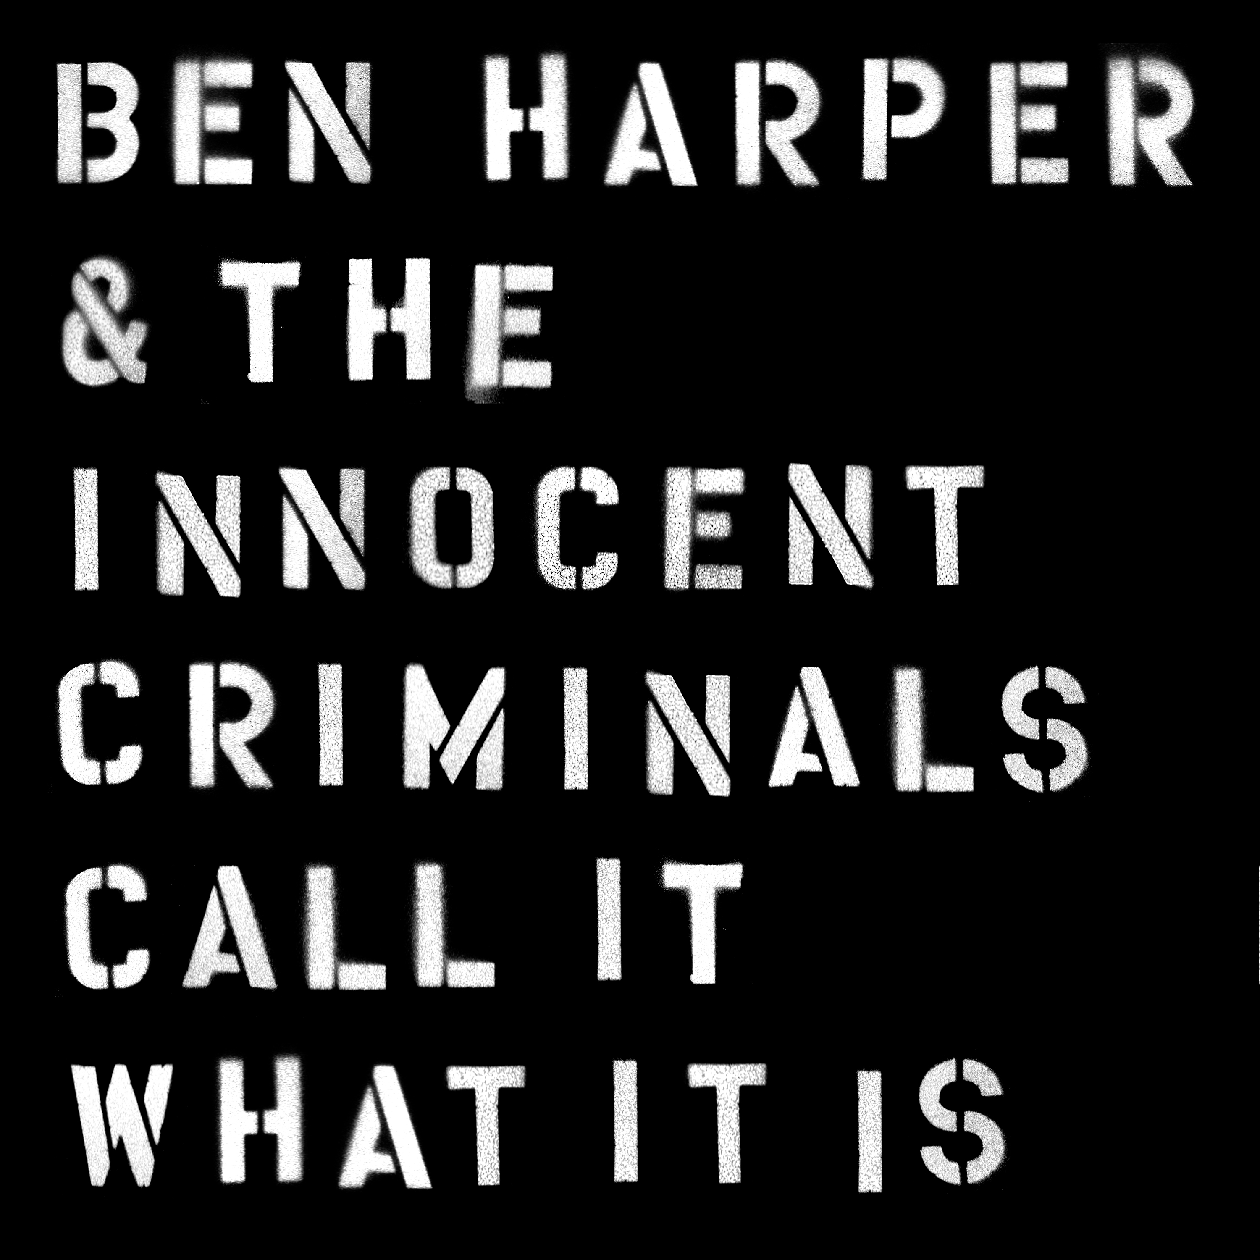

FOR IMMEDIATE RELEASE – JANUARY 22, 2016 – Ben Harper & The Innocent Criminals have reunited for Call It What It Is, their first record together in nine years, due out April 8th, 2016 on Stax Records. The beloved, soulful rock band premiered the album’s lead single, “Pink Balloon” last night on Jimmy Kimmel Live, and the song is streaming today via Billboard. Harper and The Innocent Criminals have also shared the cover art and track list for Call It What It Is, as well as new dates that expand on their previously announced headlining tour.

Read more and listen to “Pink Balloon” at Billboard.com: bit.ly/1nDrRGo

Call It What It Is is an incisive, bold, poetic statement that could only come from these long-time musical partners, one of popular music’s most essential, cohesive and dynamic ensembles.

The standout title track showcases Harper’s unmatched ability to blend the personal and political. Invoking the names of Trayvon Martin, Ezell Ford, and Michael Brown over an agitated blues riff, Harper cuts to the quick: “There's good cops / bad cops / white cops / black cops / call it what it is / Murder”. The genre-spanning collection contains many highlights including the sun-kissed groove of “Shine” and the album’s swaggering lead track “When Sex Was Dirty.”

It had been seven years since Ben Harper last played a show with the Innocent Criminals, so when the time came to reunite for a live tour in 2015, the band—percussionist Leon Mobley, bassist Juan Nelson, drummer Oliver Charles, keyboardist Jason Yates, and guitarist Michael Ward—quickly discovered that Harper had more in mind than simply revisiting the group's prodigious song catalog. In fact, Harper had been quietly amassing material for a new record and the first recording sessions were scheduled to begin even before the rehearsals for their triumphant four-night sold-out reunion run at the Fillmore in San Francisco last March.

Tracing their roots back to 1993, Ben Harper & the Innocent Criminals were at the heart of most of Harper’s projects until the band went on hiatus in 2008. The band toured internationally and released a string of groundbreaking albums, including Fight for Your Mind, The Will to Live, Burn to Shine and the GRAMMY-nominated Lifeline in 2007. The Innocent Criminals also backed Harper and The Blind Boys of Alabama on the double-GRAMMY-winning There Will Be a Light in 2005.

“I thought we would be more energized and revitalized by thinking outside the box and starting with new material in the studio before we dug into the old stuff,” said Harper of the reunion album. "It was meant to be a signpost that we're here to forge new ground musically and personally.”

Ben Harper & The Innocent Criminals North American tour dates:
4/2/16 - The Capitol Theatre - Port Chester, NY
4/3/16 - 9:30 Club - Washington, DC
4/4/16 - 9:30 Club - Washington, DC
4/6/16 - College Street Music Hall - New Haven, CT
4/7/16 - Beacon Theatre - New York, NY
4/9/16 - House of Blues Boston - Boston, MA
4/10/16 - The Fillmore - Philadelphia, PA
4/12/16 – Métropolis - Montreal, Canada
4/13/16 - Massey Hall - Toronto, Canada
4/15/16 - Royal Oak Music Theatre - Royal Oak, MI
4/16/16 - Riviera Theatre - Chicago, IL
4/17/16 - House Of Blues - Cleveland, OH
4/19/16 - Tivoli Theatre - Chattanooga, TN
4/20/16 - Tennessee Theatre - Knoxville, TN
4/22/16 - Ryman Auditorium - Nashville, TN
4/23/16 - The Orange Peel - Asheville, NC
6/23/16 - Marymoor Park - Seattle, WA
6/24/16 - McMenamins Edgefield - Troutdale, OR
6/25/16 - Les Schwab Amphitheatre – Bend, OR
6/30/16 - Revolution Concert House- Boise, ID
8/16/16 - Mountain Winery - Saratoga CA
8/17/16 - Fox Theater - Oakland, CA
8/23/16 - Humphrey's by The Sea - San Diego, CA
8/25/16 - Marquee Theatre - Phoenix, AZ

Additional US dates and a European Tour to be announced shortly.

Call It What It Is track list:

1. When Sex Was Dirty
2. Deeper And Deeper
3. Call It What It Is
4. How Dark Is Gone
5. Shine
6. All That Has Grown
7. Pink Balloon
8. Finding Our Way
9. Bones
10. Dance Like Fire
11. Goodbye To You

Pre-order Call It What It Is:
iTunes: http://smarturl.it/callitwhatitisiTunes
Amazon: http://smarturl.it/callitwhatitisamazon

http://www.benharper.com
https://www.facebook.com/benharper
https://twitter.com/benharper
https://www.youtube.com/user/benharper
http://instagram.com/benharper/

http://www.concordmusicgroup.com
http://www.staxrecords.com/

For more information please contact:

Matt Hanks – Shore Fire Media – 718-522-7171
mhanks@shorefiremedia.com

Joel Amsterdam - Stax/Concord – 310-385-4206
joel.amsterdam@concordmusicgroup.com

