Bluegrass Superstars The Earls of Leicester Unveil Rattle & Roar;
Grammy-Winning Sextet Gears Up For Summer Tour
In Support of Sophomore Outing, Due July 15

Hear “The Train That Carried My Girl From Town,”
Exclusively at Rolling Stone Country
http://rol.st/1qZi7rS

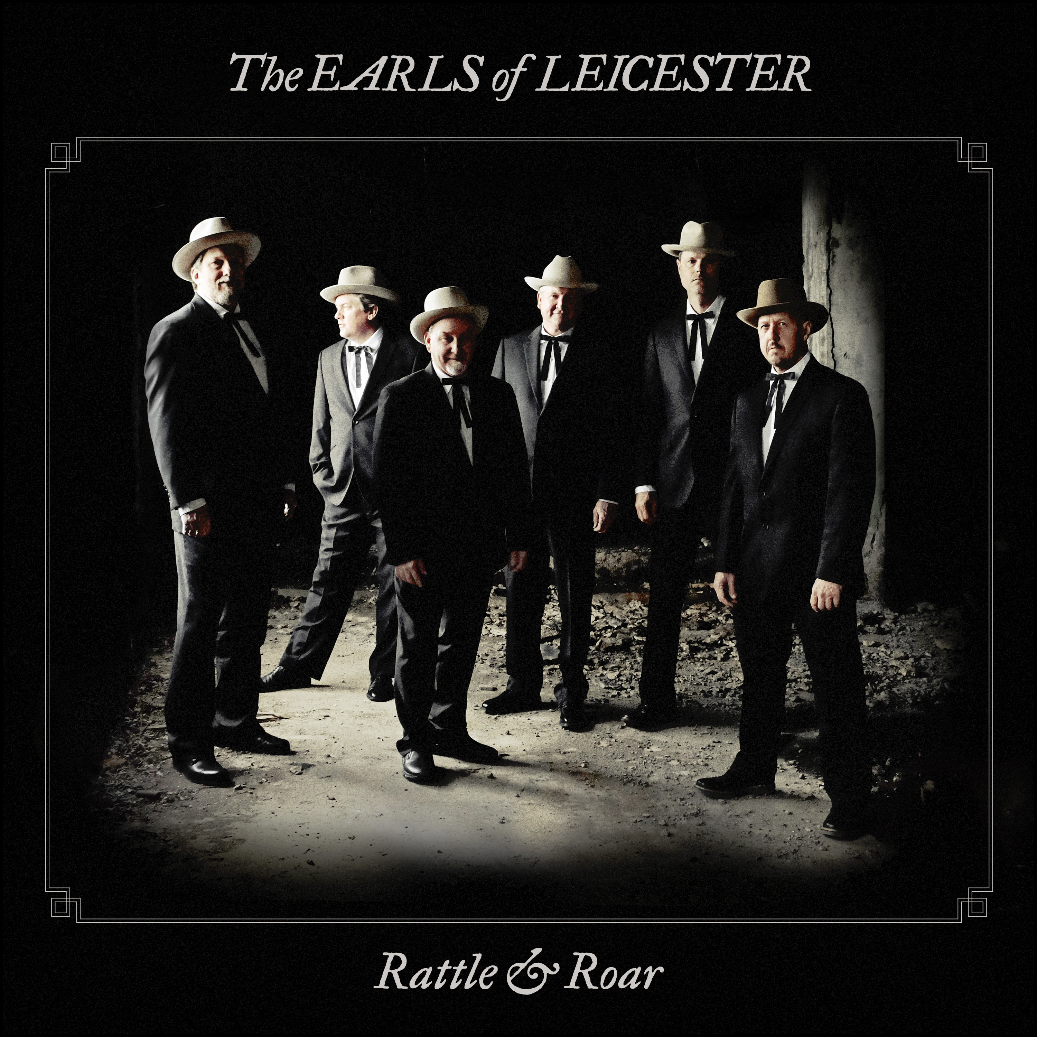

April 18, 2016 – Nashville, TN – The Earls of Leicester, the award-winning, acclaimed sextet that comprises some of the finest musicians in bluegrass, will release their second album, Rattle & Roar, July 15 on Rounder Records.

Rattle & Roar is the follow-up to the Earls’ eponymous debut, which inspired tremendous critical accolades, and earned a Grammy award for Best Bluegrass Album. The band also went on to win six International Bluegrass Music Association awards, including the coveted Album of the Year and Entertainer of the Year honors.

With Rattle & Roar, the Earls – Barry Bales, Shawn Camp, Charlie Cushman, Jerry Douglas, Johnny Warren, and Jeff White -- have conjured up a fresh batch of Lester Flatt and Earl Scruggs songs, delivered with their now signature blend of homage, virtuosity, and perspective.

The inimitable Douglas remains the band’s producer and hypnotic Dobroist; blue-ribbon songwriter, singer, and producer Camp still soars on lead vocals and guitar; revered multi-instrumentalist and sideman Jeff White now deftly handles high harmony and mandolin; ace Nashville banjoist Charlie Cushman tackles banjo and guitars; topflight musician Johnny Warren cuts in radiantly on fiddle; and the esteemed Barry Bales, Douglas’ longtime bandmate in Alison Krauss and Union Station, holds magnificently steady on vocals and bass.

Those collaborative deep dives into Flatt and Scruggs by some of the best living musicians––bluegrass or otherwise––built Rattle & Roar, a collection spanning exhumed nuggets and familiar favorites. To capture the feel of a live show, the album was recorded in one room, with all of the band members in a line, no separation between them. “This is about as live as a record can be. I hope listeners can hear the fun that’s going on,” Camp says. “They’re listening to everything go down, right then, at that moment. A lot of music can be made in an instant.”

Rattle & Roar pulses with impish joy and immediacy, uniquely showcasing artists at the top of their game as they delight in their work not just as creators, but also as fans.

The songs’ themes of spirituality, love lost or found, war, and ex-convicts still resonate. The album opener, “The Train That Carried My Girl From Town,” delights in furious revenge wishes delivered with naked sincerity. “I wish to the Lord that train would wreck / kill the engineer and break that fireman’s neck,” Camp confesses somewhat sweetly, then follows with plenty of other innuendo and lines sure to make listeners wonder if they heard him correctly. Rolling Stone Country premiered the track exclusively. Listen to it here: http://rol.st/1qZi7rS

“All I Want Is You” is a showpiece, offering Camp a chance to croon. “Lester Flatt was sort of the Bing Crosby of this genre of music,” Douglas says. “He could have been a big band singer. He sang the entire melody, all changes, augments––they didn’t have to be whole notes. He really stretched, and so does Shawn. I love hearing him sing it.”

Harmony-drenched “You Can Feel It in Your Soul” bounces with gospel fervor cushioned by warm strings, while “I’m Working on a Road to Gloryland” features multiple vocal bows worthy of a riverside revival.

Instrumentals including “Flint Hill Special” and “Buck Creek Gal” are spirited back-and-forths between giants. “You can’t pretend or fake your way through this stuff,” Camp says. “It’s got to be right, or it’s wrong. And when we play together, it’s right.”

The lush instrumental “Steel Guitar Blues” was discovered on an old reel-to-reel recording, as was “Pray for the Boys,” the album’s solemn closer. “My Mother Prays So Loud in Her Sleep” features a three-part vocal ascension that the Earls took pains to get right. “When we were rehearsing, we all got our heads together, listened to the original, and asked, ‘Okay, who is that on the high part? Is that Curly [Seckler] or Lester? We scoped in, and now, we’re sure it’s Lester,” says Douglas. “It’s things like that that we do together that make this band really work and exceptional.”

As much as the Earls are a reincarnation of a sound that older generations have missed––an unexpected Proustian take on bluegrass––the band is especially interested in reaching new ears. “I hope people who don’t know Flatt and Scruggs hear this and think it’s totally new music,” Douglas says. “Then, I hope they find out what we’re doing and go out and buy every Flatt and Scruggs record they can find.”

The Earls of Leicester will be on tour throughout 2016. More dates will be announced in the coming weeks.

For more information, please contact Regina Joskow rjoskow@rounder.com, 917-532-5687 or Ashley Moyer ashley.moyer@concordmusicgroup.com, 615-928-4777.

Track list:

- The Train That Carried My Girl from Town (2:46)
- Why Did You Wander? (2:49)
- All I Want Is You (3:04)
- Steel Guitar Blues intro (0:10)
- Steel Guitar Blues (2:35)
- You Can Feel It in Your Soul (3:02)
- A Faded Red Ribbon (2:48)
- Just Ain’t (2:14)
- Mother Prays Loud In Her Sleep (3:33)
- I’m Working On A Road (To Glory Land) (3:00)
- Will You Be Lonesome Too? (3:04)
- Flint Hill Special (2:38)
- What’s Good for You (Should Be Alright for Me) (2:44)
- The Girl I Love Don’t Pay Me No Mind (2:50)
- Branded Wherever I Go (2:33)
- Buck Creek Gal (1:29)
- Pray For the Boys (3:00)

The Earls of Leicester – Tour Dates
4.28 – 5.1 Merlefest Wilkesboro, NC
5.1 Stagecoach Festival Indio, CA
5.26 – 5.29 DelFest Cumberland, MD
6.3 Bluegrass on the Plains Festival Auburn, AL
7.15 Grey Fox Bluegrass Festival Oak Hill, NY
7.29 Rockygrass Festival Lyons, CO
9.9 – 9.10 Mountain Song Festival Brevard, NC
9.16 Daily & Vincent Land Fest Denton, NC
10.15 Bloomin Bluegrass Farmers Branch, TX

Pre-order links:
D2C: http://smarturl.it/EarlsRNRStore
Amazon: http://smarturl.it/EarlsRNRCD

Online media kit: http://mediakits.concordmusicgroup.com/p/rattle-and-roar/

