The Seldom Scene Return with Changes

Featuring Boldly Reimagined Songs By Bob Dylan, John Prine, Gordon Lightfoot, Phil Ochs, James Taylor, Townes Van Zandt and others
Cover of Fred Neil-Penned Nilsson 1969 Smash "Everybody's Talkin'" Out Today
Listen here
First Album In Five Years Available June 7, 2019

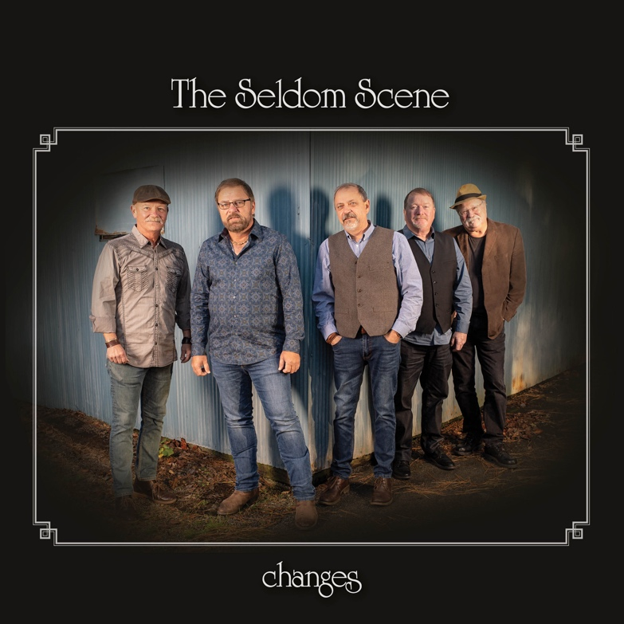

March 29, 2019 - Nashville, TN - Since forming nearly 50 years ago, The Seldom Scene has brought both freewheeling joy and immaculate musicianship to their inventive take on bluegrass, offering up spirited interpretations of songs from limitless genres. On the new album Changes, The Seldom Scene more than proves itself up to task. Co-produced by the band and Rounder Records co-founder Ken Irwin, the album also spotlights The Seldom Scene's sheer ingenuity as song arrangers, with even the most starkly composed tracks taking on wondrously intricate textures and tones. Changes is due June 7.

On this album, the band sharpens their focus to a highly specific body of work: songs first recorded in the 1960s and very early '70s, rooted in the archetypal storytelling of classic singer-songwriters. Taking on the music from iconic artists like Bob Dylan, John Prine, and Townes Van Zandt.

Opening with a brightly tumbling, banjo-driven reimagining of "Everybody's Talkin'"-the Fred Neil-penned lament made mega-hit by Harry Nilsson in 1969-Changes both upholds that timeless quality and introduces an entirely fresh sensibility into each song.

Listen to "Everybody's Talkin' here.

Lifted from a soul-stirring version of Phil Ochs's most celebrated love song, the title to Changes also reflects a major shift for the band: it's the first Seldom Scene album that doesn't feature a founding member, following the 2016 retirement of banjo player Ben Eldridge. "I suppose it's a gutsy move to keep this going without a single original member left," Connell admits. "But we've all been doing this for a quarter-century now, so if anybody can carry that mantle, it's us."

Throughout Changes, The Seldom Scene's crystal-clear harmonies and palpable camaraderie carry the songs through countless moods, from the homesick yet hopeful anticipation of "Steel Rail Blues" (originally recorded by Gordon Lightfoot in 1966) to the lovestruck sorrow of "Darcy Farrow" (Steve Gillette, 1965) to the reflective intensity of "Bob Dylan's Dream" (1963). On their brilliantly buoyant update of John Prine's 1971 meditation "Good Time," the band attains an especially striking alchemy, reshaping a heavy-hearted folk tune into something straight out of the Flatt & Scruggs repertoire.

On the album-closing "Sweet Baby James," The Seldom Scene revisits a song previously recorded for their 1972 debut Act I (widely regarded as one of the most influential records in the history of progressive bluegrass). "That's the only one of these songs that we've been doing live-people kept coming up to us at the merch table and asking if we had it on record, so it was a no-brainer," says Connell. In breathing new life into James Taylor's 1970 lullaby, the band made careful use of Reid's longtime study of Taylor's singular guitar style, giving way to a gracefully sculpted track still closely centered on the melancholy cowboy tale captured in the lyrics.

The Seldom Scene is looking forward to the next phase of the album's lifespan: taking their newly recorded songs out on the road, in a live show that joyfully balances the band's most recent work with plenty of fan favorites and audience requests. A full list of tour dates is below.

Changes is due June 7.

Changes Track List:
1. Everybody's Talkin' (Fred Neil)
2. Steel Rail Blues (Gordon Lightfoot)
3. Darcy Farrow (Stephen B. Gillette-Thomas Campbell)
4. Louise (Paul Siebel)
5. A Good Time (John Prine)
6. Seven Bridges Road (Steve Young)
7. Bob Dylan's Dream (Bob Dylan)
8. Pack Up Your Sorrows (Richard Farina-Pauline Marden Bryan)
9. Changes (Phil Ochs)
10. I'll Be Here In the Morning (Townes Van Zandt)
11. Morning Sky (Dan Fogelberg)
12. Sweet Baby James (James Taylor)

Tour Dates:
4/6/2019 Hylton Performing Arts Center Manassas, VA
4/12/2019 Chandler Center for the Arts Randolph, VT
4/13/2019 Belleville Congregational Church Newburyport, MA
4/27/2019 Charm City Bluegrass Baltimore, MD
5/9/2019 Denton Farm Park Denton, NC
5/11/2019 BlackRock Center for the Arts Germantown, MD
5/17/2019 Roanoke Island Festival Park Manteo, NC
5/18-5/19/2019 Gettysburg Bluegrass Festival Gettysburg, PA
5/24/2019 The Birchmere Alexandria, VA
5/25/2019 Newtown Heritage Festival Stephens City, VA
6/7/2019 Circa Blue Fest Martinsburg, WV
6/8/2019 Festival of the Bluegrass Lexington, KY
6/9/2019 Bean Blossom Bluegrass Festival Bean Blossom, IN
7/4/2019 Starvy Creek Bluegrass Festival Conway. MO
7/5/2019 Sally Mountain Bluegrass Festival Queen City, MO
7/26-7/27/2019 GorgeGrass Stevevson, WA
7/28/2019 The Freight & Salvage Berkeley, CA
8/4/2019 Garrett Lakes Arts Festival McHenry, MD
8/17-8/18/2019 Gettysburg Bluegrass Festival Gettysburg, PA
8/30/2019 Sam Jam Bluegrass Festival Piketon, OH
8/31/2019 Chet Kingery Memorial Bluegrass Festival Arthur, IL
9/12/2019 Thousand Trails Bluegrass Festivals Gloucester, VA
9/27/2019 The Birchmere Alexandria, VA
9/28/2019 Bluegrass by the Bay Berlin, MD
11/15/2019 Imperial Theatre Augusta, GA
11/29/2019 The Birchmere Alexandria, VA
12/30/2019 The Rams Head Annapolis, MD
12/31/2019 The Birchmere Alexandria, VA

###

