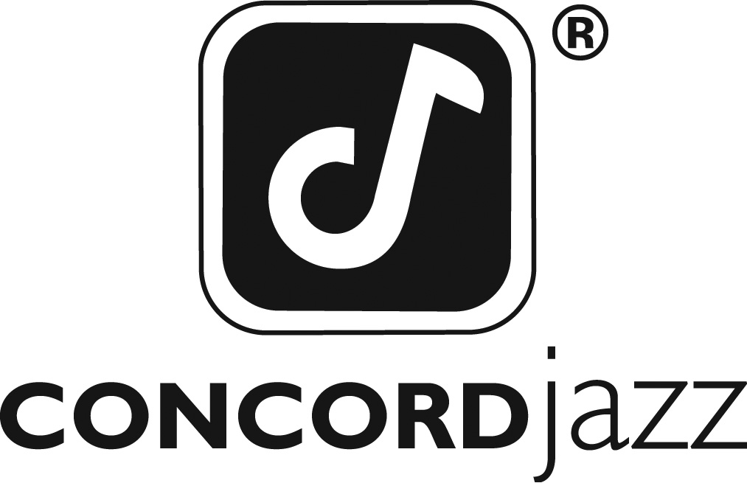

ON APRIL 24TH, CONCORD JAZZ RELEASES
ELLA 100: LIVE AT THE APOLLO!

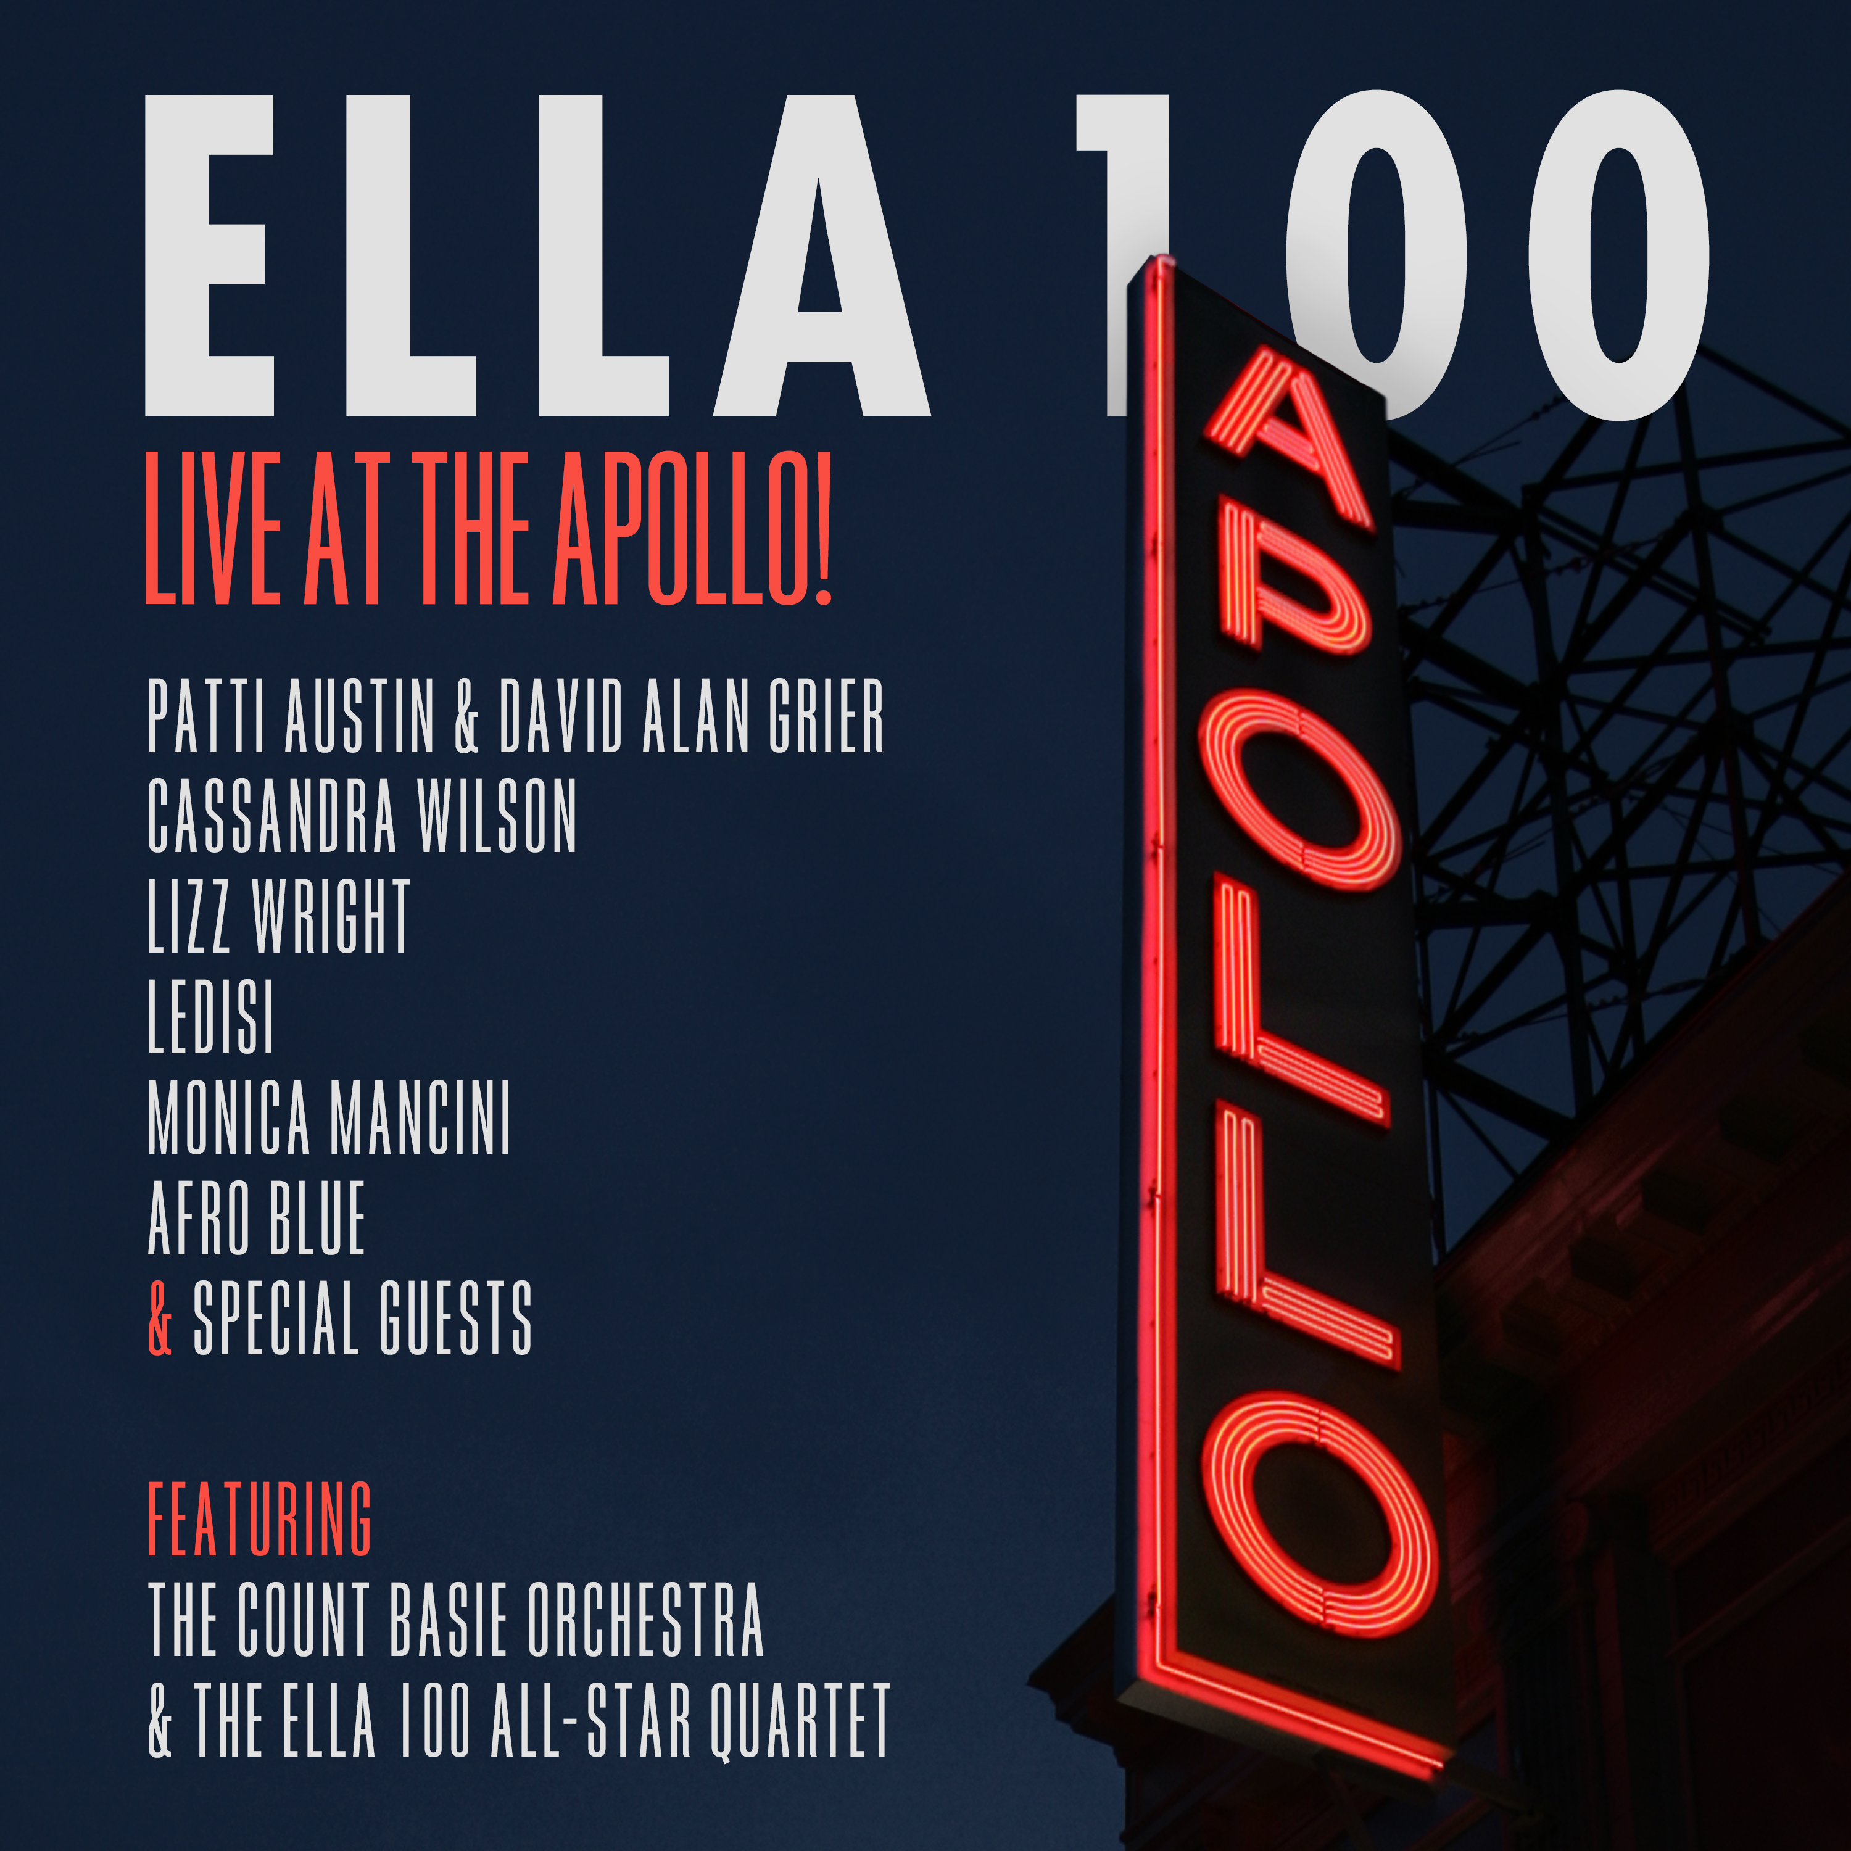

The historic concert brought together legends and multiple GRAMMY Award-winning artists to the hallowed stage of the Apollo Theater to celebrate the greatest jazz singer of them all, Ella Fitzgerald…from where it all began

“One of the most spectacular concerts I’ve had the pleasure to attend
in my nearly fifty years of listening to jazz.” -Russ Musto/Downbeat

For Immediate Release – Ella 100: Live at the Apollo!, set for release on April 24th, 2020 via Concord Jazz, celebrates the music and life of the “First Lady of Song,” Ella Fitzgerald, hailed as perhaps the greatest singer in the history of jazz. Recorded live at the storied Harlem N.Y. venue in front of an ecstatic audience, the concert and recording, produced by the eight-time GRAMMY and Emmy Award recipient and former Fitzgerald musician Gregg Field, features dynamic and loving tributes from a parade of contemporary vocal and musical giants and co-hosted by GRAMMY award winner Patti Austin and the multi-TONY award nominated actor/singer David Alan Grier.

In addition to Austin and Grier, the concert features performances by Andra Day, Ledisi, Lizz Wright, Cassandra Wilson, Monica Mancini and the award-winning a cappella vocal group from Howard University, Afro Blue. Accompanying these world-class vocalists is none other than the Count Basie Orchestra and strings, so effectively presenting the music of Ella and the renowned orchestra with whom Ella so often collaborated. Also featured, and to celebrate Ella’s famous quartet, is the deeply swinging Ella 100 All-Star Quartet with Shelly Berg, Nathan East, Brian Nova and Field, who channel the spontaneous spirit direct from Ella.
At just 17, Ella entered the famous Apollo Amateur Contest to dance but made a last instant and fateful decision to sing for the notoriously difficult-to-please Apollo Amateur Night crowd. Her shockingly original and vibrant delivery of Hoagy Carmichael’s “Judy” with a range and depth simply unheard-of—especially from one so young—brought the house down, thus launching a remarkable career that changed 20th Century music and has not been equaled to this day.

Ella 100: Live at the Apollo! opens with a vintage radio broadcast of that fateful evening and features Grier with a faithful recreation of original Apollo Amateur Contest host Ralph Cooper introducing the young Ella and her unexpected performance of “Judy,” sung here by the fabulous 17 year old vocalist Ayo (Ayodele Owolabi). Grier then offers his opening remarks and introduces Austin who comes out swinging for the fences with delicious takes on Ella’s signature hit “A Tisket, A Tasket”, and then authentically brings the Harlem swing-era centric “When I Get Low, I Get High” back to the Apollo stage.
To the complete surprise of the enthusiastic Apollo audience, Grier returns shortly thereafter with a funky, contemporary reading of “Do Nothin’ Till You Hear From Me”, effectively demonstrating what his three Tony-nominations sound like when on full display in Ella and Ellington land.

“I didn’t know David could sing until I heard him as Sportin’ Life in the recent Broadway revival of Porgy and Bess,” that he received a Tony nomination for” says producer Field, who played drums with both Fitzgerald and Basie during his own long, distinguished career and assembled the lineup for Ella’s 100th celebration.

“I’ve been working with Patti Austin for years and actually produced her ‘For Ella’ album way back when and suggested that she and David co-host the celebration.”

They were quickly in and Kamila Forbes and Laura Greer from the Apollo and I started putting the evening together. It was an enthusiastic yes from all the artists we invited as they each felt a unique kinship to Ella and wanted to perform her music on the Apollo stage.”

In some cases, the artists themselves like Austin, Monica Mancini and Field all had a personal relationship with Ella. “The more we could bring artists into the line-up that had a direct association with Ella the more authentic this evening would become.” Field noted.
Andra Day (who appears on CD release only) performing “Ain’t Misbehavin’” (featuring a later Nelson Riddle arrangement written for Ella and never recorded), a pair of tunes from Lizz Wright, “Love You Madly” (with The Ella 100 All-Star Quartet) and the show stopping “The Nearness of You,” plus a stunning duo interpretation of the ballad “Once in a While” featuring Mancini and Joe Pass protégé guitarist Brian Nova—in the spirit of Ella and Joe Pass—are among the highlights of the evening. Cassandra Wilson turns in a deeply passionate and blue reading of “Cry Me a River,” and 12-time GRAMMY Award-nominated singer Ledisi brings her deep New Orleans jazz roots to Ella’s “Honeysuckle Rose.”
Another high point features the vocal choir Afro Blue, bringing back to the Apollo stage the grand tradition of a’cappella singing, harmonizing splendidly on “Lady Be Good.” They then join Austin for a ripping scat-infused romp through Ella’s classic “How High the Moon,” followed by the Count Basie Orchestra, with its explosive instrumental workout of the appropriately named “Back to the Apollo,” reminding contemporary audiences why the Basie band remains “The most explosive force in Jazz”

To round out the concert and celebrate the great Ella pairings, the concert includes two duets featuring co-hosts Austin and Grier: first a medley of Gershwin standards, “I Loves You Porgy” and “There's A Boat Dat’s Leavin’ Soon for New York” celebrating the great Ella and Louis Armstrong album Porgy & Bess, and finally the perfect closer to blow the roof off the Apollo, “You’ll Have to Swing It (Mr. Paganini),” bringing us full circle and back to one of Ella’s earliest hits recorded back in 1936 when she was the girl-singer for the great Chick Webb Orchestra.

And as the ultimate encore, a special and rare track of Ella herself performing an astoundingly personal version of “People,” poignantly expressing her love for the fans, the artists and musicians that in turn loved her so dearly.

For Field and the Apollo, the opportunity to present the broad scope of Fitzgerald’s music, especially in the context of the legend’s centennial birthday, was a dream realized. And presenting the concert on the stage of the fabled Apollo, where it all began for Fitzgerald, made it that much more than just another collection of songs performed in tribute.
Field fondly recalls in the minutes just prior to the concert starting, the gravitas of where they were and what they were collectively about to do. “The curtains were closed and we were just about to let it fly when there was a spirit that hit all of us I don’t believe I’ve experienced on any stage. I turned to the band and choking up a bit said, ‘Hey guys, that’s the spot where Ella sang for the very first time. Let’s play this one for Ella.”’

“We all felt the history. It was palpable. Knowing where it all began with this confluence of talent could have only happened that night on the Apollo stage. After we played our last note,” Field adds, “a couple of the hardened NY string players came up to me and said, ‘That was the most amazing night I’ve ever experienced.’ The Ella stars aligned and shined brightly that evening at the Apollo and created an unforgettable and timeless moment for all those lucky enough to be in the house… or on the stage.”

On November 21, 1934, a shy 17-year-old girl walked onto the stage of Harlem’s famed Apollo Theater fully intending to show the Amateur Night audience just how well she could dance. Instead, she made a last-minute decision to sing.

American music would never be the same.
Track Listing:
# | Track Name | Performer
1 | Vintage 1934 “Apollo Amateur Night” Radio Broadcast / “Judy” | David Alan Grier & Ayo
2 | Ella 100 Co-Host David Alan Grier Opening | David Alan Grier
3 | A Tisket-A Tasket | Patti Austin & The Count Basie Orchestra
4 | When I Get Low I Get High | Patti Austin & The Count Basie Orchestra
5 | Ain’t Misbehavin’ ** | Andra Day & The Count Basie Orchestra **
6 | Do Nothin’ Till You Hear From Me | David Alan Grier & The Count Basie Orchestra
7 | Love You Madly | Lizz Wright & The Ella 100 All-Star Quartet
8 | The Nearness Of You | Lizz Wright & The Ella 100 All-Star Quartet
9 | Oh, Lady Be Good | Ayo & Afro Blue
10 | How High The Moon | Patti Austin, Afro Blue & The Count Basie Orchestra
11 | Back To The Apollo! (Apple) | The Count Basie Orchestra
12 | I Loves You, Porgy / There’s A Boat Dat’s Leavin’ Soon For New York | Patti Austin, David Alan Grier & The Count Basie Orchestra
13 | Cry Me A River | Cassandra Wilson & The Count Basie Orchestra
14 | Honeysuckle Rose | Ledisi & The Count Basie Orchestra
15 | Once in A While | Monica Mancini & Brian Nova
16 | You’ll Have To Swing It (Mr. Paganini) / Paganini Bows Reprise | Patti Austin, David Alan Grier & The Count Basie Orchestra
17 | People | Ella Fitzgerald
**ANDRA DAY APPEARS ON CD RELEASE ONLY

Online Media Kit: http://mediakits.concordmusicgroup.com/p/ella-100/

For more information:
Mike Wilpizeski / Chart Room Media at 718-459-2117
Mikew@chartroommedia.com

