

NEW ALBUM DELIVERS JOAN BAEZ’S HISTORIC WOODSTOCK PERFORMANCE,
MARKING THE FIRST AVAILABILITY OF THIS HOUR-LONG SET IN ITS ENTIRETY

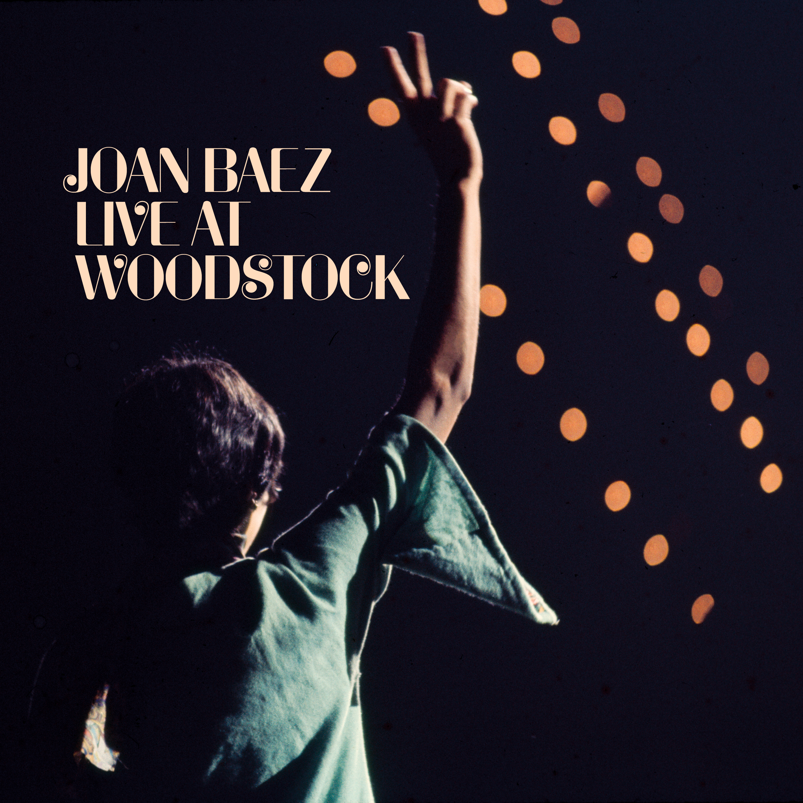

LIVE AT WOODSTOCK – OUT TODAY
ON ALL STREAMING AND DIGITAL PLATFORMS
Click here to stream Joan Baez’s Live at Woodstock
Los Angeles, CA (July 26, 2019)—Craft Recordings is proud to announce the release of Joan Baez’s Live at Woodstock, available today on all digital and streaming platforms. For the very first time, fans can hear the influential folk singer’s entire set, as it was performed at the historic festival 50 years ago. Live at Woodstock features nearly an hour of music and interstitial stories, including “Sweet Sir Galahad,” “I Shall Be Released,” and a stunning a cappella rendition of “Swing Low Sweet Chariot.”
It was almost 1 a.m. when Joan Baez walked on stage to close out the rainy first night of Woodstock. With her acoustic guitar in hand, the visibly pregnant singer-songwriter kicked off her set with a joyful rendition of the beautifully simple Edwin Hawkins gospel tune, “Oh Happy Day.” As she segued into Tom Paxton’s “The Last Thing on My Mind,” Baez wished the audience a tongue-in-cheek “good morning.”
The weeks leading up to the three-day festival had been tumultuous for Baez. Just one month before, the singer’s then-husband, David Harris, had been arrested for draft resistance. The anti-war activist and founder of The Resistance—an organization that encouraged young men to return their draft cards in protest of Vietnam—had just begun serving a 15-month sentence in prison. He was, understandably, on his wife’s mind, and was a prevailing theme throughout the show. A few songs into her set, Baez spoke to the audience about Harris, assuring them that “He’s fine, and we’re fine too.” As a tribute to her husband, Baez performed “Joe Hill,” a 1936 folk song about the trade union activist.
Joan was joined by two members of Harris’ Resistance movement, Jeffrey Shurtleff and Richard Festinger who, along with Baez, called themselves the Struggle Mountain Resistance Band (named after the California-based draft-resistance commune in which Harris and Baez lived). Their songs together included a rousing rendition of The Byrds’ “Drug Store Truck Drivin’ Man” and Willie Nelson’s “One Day at a Time.”

Baez closes out her set by asking the audience to join her in singing “We Shall Overcome,” dedicated to Harris. As a special bonus, the last track on the album replays the evening’s final announcements from the master of ceremonies, Chip Monck, which will make listeners feel like they are right there on that muddy farm in Bethel, NY. In her 1987 memoir, And a Voice to Sing With, Baez called Woodstock “Three extraordinary days of rain and music,” adding that, “I just stood up there in front of the residents of the golden city who were sleeping in the mud and each other’s arms, and I gave them what I could at the time. And they accepted my songs. It was a humbling moment, in spite of everything. I’d never sung to a city before.”

Singer, songwriter and activist Joan Baez is one of the most significant figures in modern music, with a career that has spanned over six decades. Though often identified most closely with the folk movement of the sixties, her influence has extended far beyond that. A master interpreter of songs, Baez received critical and commercial success early on, recording an eclectic mix of traditional ballads, gospel and folk music. She focused awareness on songwriters ranging from Woody Guthrie to Bob Dylan, Phil Ochs, Richard Fariña, Leonard Cohen, and Tim Hardin, among others. With the passage of time, the list of songwriters whose work she recorded or performed grew to encompass Jackson Browne, Janis Ian, John Prine, Stevie Wonder, Steve Earle, Tom Waits, and many others, including songs written by Joan herself.

Many traditional songs that Joan introduced on her earliest LPs found their way into the rock vernacular: “House Of the Rising Sun” (the Animals), “John Riley” (the Byrds), “Babe, I’m Gonna Leave You” (Led Zeppelin), “Jackaroe” (Grateful Dead), and “Long Black Veil” (the Band), to name a few. A multitude of British acts who trace their origins to Fairport Convention, Pentangle, and Steeleye Span were inspired by Joan’s versions of “Geordie,” “House Carpenter,” and “Matty Groves.”

Baez’s career has never slowed down. The GRAMMY® Lifetime Achievement Award Recipient and Rock and Roll Hall of Fame inductee has released over 30 studio and live albums to-date, and still actively tours. Her GRAMMY®-nominated album, Whistle Down the Wind, debuted last year at #18 on Billboard’s Top Current Albums chart and #4 on the Americana/Folk Albums chart—Baez’s strongest chart position since 1975’s Diamonds & Rust. Baez is currently in Europe for the final run of her extensive “Fare Thee Well Tour.” Visit JoanBaez.com for more information.

Click here to stream Live at Woodstock.
Track Listing
  - Oh Happy Day
  - The Last Thing On My Mind
  - I Shall Be Released
  - He's Fine, And We're Fine, Too
  - Joe Hill
  - We Three Together Constitute The Struggle Mountain Resistance Band
  - Sweet Sir Galahad
  - Hickory Wind
  - Drug Store Truck Drivin' Band
  - One Day At A Time
  - Take Me Back To The Sweet Sunny South
  - Warm And Tender Love
  - Swing Low, Sweet Chariot
  - I Think It's Amazing The You People Are Still Awake
  - We Shall Overcome
About Craft Recordings:
Craft Recordings is home to one of the largest and most prestigious collections of master recordings and compositions in the world. Its rich and storied repertoire includes legendary artists such as Joan Baez, Ray Charles, John Coltrane, Creedence Clearwater Revival, Miles Davis, Bill Evans, Vince Guaraldi, John Lee Hooker, Little Richard, Nine Inch Nails, Thelonious Monk, Otis Redding, R.E.M. and Traveling Wilburys, to name just a few. Renowned imprints with catalogs issued under the Craft banner include Concord, Fania, Fantasy, Milestone, Musart, Nitro, Prestige, Riverside, Rounder, Specialty, Stax, Sugar Hill, Vanguard and Vee-Jay Records, among many others. Craft creates thoughtfully curated packages, with a meticulous devotion to quality and a commitment to preservation-ensuring that these recordings endure for new generations to discover. Craft Recordings is the catalog label team for Concord Recorded Music. For more info, visit CraftRecordings.com and follow on Facebook, Twitter, Instagram, YouTube, and Spotify.

