FOR IMMEDIATE RELEASE

CRAFT LATINO TO UNVEIL THE FIRST BATCH OF CLASSIC FANIA VINYL REISSUES

CELIA CRUZ & TITO PUENTE’S ALMA CON ALMA, WILLIE COLÓN’S THE HUSTLER, FANIA ALL STARS’ LIVE AT YANKEE STADIUM AND CELIA CRUZ & JOHNNY PACHECO’S CELIA & JOHNNY
AVAILABLE OCTOBER 25TH ON CRAFT LATINO

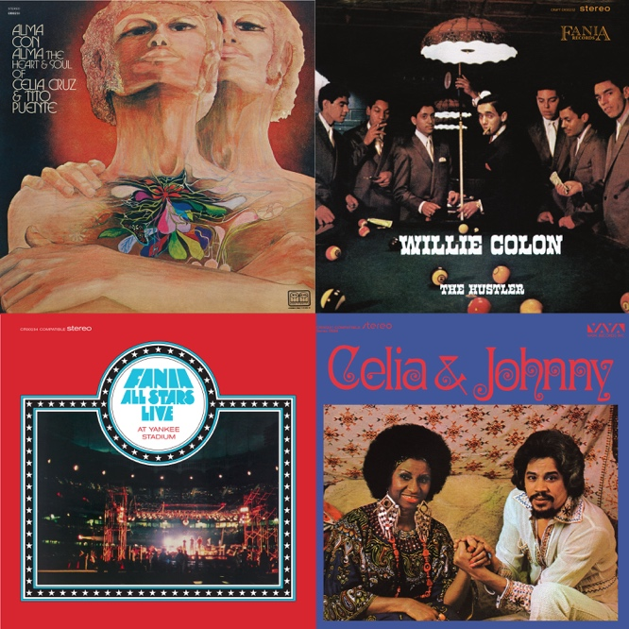

Click here for the Online Media Kit
Click here to Pre-Order

Los Angeles, CA – In 1964, a young musician from the Dominican Republic by the name of Johnny Pacheco teamed up with ambitious Italian-American lawyer Jerry Masucci for the creation of a record label in New York. Named Fania, the brand-new company captured the sheer excitement of Afro-Caribbean music as it was just beginning to incorporate elements of soul, R&B and jazz into a vibrant sonic stew known as salsa.

Fania grew in sales and scope at a rapid pace, documenting the New York Salsa Explosion of the ’70s and establishing itself as the Latin equivalent of Motown. Its catalogue of masterpieces from the ’60s, ’70s and ’80s remains one of the most prodigious bodies of work in all of Latin music.

On October 25th, Craft Latino, the Latin arm of Craft Recordings, will unveil the first batch of vinyl reissues to be released since the Fania catalogue was acquired by Concord in 2018. Cut from the original analog masters by Kevin Gray at Cohearent Audio, these four LPs offer an exciting and intriguing sample of Fania’s salsa magic. There’s Alma Con Alma — an electrifying collaboration between Cuban powerhouse Celia Cruz and timbales king Tito Puente. Released in 1968, The Hustler is the second album by visionary producer Willie Colón and his partner in crime, Puerto Rican singer Héctor Lavoe. The Fania All Stars’ double-LP set Live At Yankee Stadium captures the label’s own mega-orchestra recorded in concert at the height of its powers — an album that was inducted into the National Recording Registry in 2003. Lastly, Celia & Johnny, the Queen of Salsa’s 1974 artistic tour de force, in collaboration with Fania co-founder and flautist Johnny Pacheco, is a salsa masterpiece that will be available exclusively through Vinyl Me, Please Classics as the October Record of the Month!

Strategically designed as an ideal introduction to the Fania aesthetic, and timed to coincide with Hispanic Heritage Month, the releases also illustrate the label’s breadth. From salsified Cuban standards and funky boogaloos to raucous jam sessions and trombone-heavy dancefloor scorchers, this initial collection paints a vivid picture of Afro-Caribbean music as a genre marked by wide stylistic variety.

During the late ’60s, Fania thrived on contrasts. On the one hand, it championed the albums recorded by the prolific Johnny Pacheco, honoring the Cuban roots of tropical music with elegant charanga instrumentations and a certain innocence of spirit. At the same time, it was also the label of choice for young musicians of Nuyorican and Puerto Rican origin who wanted to disrupt the cultural status quo with the rebellious energy of fresh sounds.

Trombonist, singer/songwriter and producer Willie Colón was one such artist, and his 1968 LP The Hustler still breathes with unpredictability, raw arrangements and the kind of visceral approach to Afro-Cuban beats that would come to define the essence of ’70s salsa. In retrospect, The Hustler sounds remarkably self-assured for a sophomore effort, particularly thanks to the timeless vocalizing of Héctor Lavoe, the closest to a rock star that salsa has ever known. On tracks such as “Que Lío” and “Eso Se Baila Así,” Lavoe’s soulful singing brims with humor and personality, while the piano licks by the late Markolino Dimond are, just by themselves, worth the price of admission. This reissue is pressed on 180-gram vinyl with the original artwork faithfully replicated on a classic tip-on record jacket.

Released in 1970, Alma Con Alma is a relatively obscure LP — one of a handful of masterpieces that Tito Puente and Celia Cruz recorded together between the late ’60s and the early ’70s. In later decades, both artists would remember these releases as some of the best work of their careers, lamenting the fact that poor promotion at the time caused these excellent albums to go virtually unnoticed. But the inspiration is certainly there, as demonstrated by the exotic strains of “Sahara” — with a solemn Celia chanting about the desert — and the exuberant energy of “Salsa de Tomate,” where Puente’s brass section and syncopated percussion are placed at the service of Celia’s powerhouse vocals. Pressed on 180-gram vinyl, Alma Con Alma also features faithfully replicated artwork printed on a tip-on jacket.

Whereas Alma Con Alma could find redemption as a newly discovered masterpiece, the Fania All Stars’ Live At Yankee Stadium is widely known as a testament of the salsa concert experience. It is difficult to imagine the Anglo equivalent of this band — picture John Lennon, Bob Dylan, Joni Mitchell and Elton John performing together as part of a touring group, and you’re beginning to get a feel for the star power involved in the Fania All Stars. But in this particular orchestra, even the instrumentalists — keyboardist Larry Harlow, bongosero Roberto Roena, conguero Ray Barretto — were bandleaders and legends in their own right.

By the time the Fania All Stars performed at Yankee Stadium in 1973, the salsa explosion had already become a mainstream phenomenon. Here we get a snapshot of a genre at its ultimate peak, and the performances are appropriately epic, from Celia Cruz’s 12-minute long “Bemba Colorá” to Héctor Lavoe’s moving “Mi Gente” — a Johnny Pacheco composition — and the warmth in Ismael Miranda’s delivery throughout the jazzy “Qué Rico Suena Mi Tambor.” Live At Yankee Stadium Volumes 1 & 2 are released here as a 2-LP set for the first time!

If one had to pick a single Celia Cruz LP for the proverbial desert island, 1974’s Celia & Johnny would be the obvious choice. In a way, it crystallizes Johnny Pacheco’s entire career as an impossible dream that comes true: a musician who grows up idolizing Cuba’s La Sonora Matancera, then ends up recording a best-selling album of modernized classics with the orchestra’s former star singer. Cruz always collaborated with superlative producers and musical directors, but there was something about her partnership with Pacheco that brought her best qualities to the forefront. She sounds positively blissful on “Químbara” — an essential salsa nugget to this day — then travels to Peru for an earthy take on “Toro Mata,” before showcasing endless amounts of tenderness on the velvety bolero “Vieja Luna.”

On October 25th, Vinyl Me, Please will be releasing exclusive 180-gram collectible color variants of these Fania titles. The Hustler in custard yellow vinyl, Alma Con Alma in olive green vinyl, and Live At Yankee Stadium in fire red vinyl. Click here to pre-order.

More LP reissues will follow soon, continuing an ongoing exploration and reevaluation of the Fania treasure trove.

—ERNESTO LECHNER

###
About Craft Latino:
Craft Latino is home to one of the largest and most prestigious collections of Latin music master recordings and compositions in the world. Its rich and storied repertoire includes legendary artists such as Antonio Aguilar, Joan Sebastian, Pepe Aguilar, Celia Cruz, Héctor Lavoe, Willie Colón, Ray Barretto, La Lupe, Ruben Blades and the Fania All Stars, to name just a few. Renowned imprints with catalogs issued under the Craft banner include Musart, Fania, TH, Panart, West Side Latino and Kubaney, among many others. Craft creates thoughtfully curated packages, with a meticulous devotion to quality and a commitment to preservation, ensuring that these recordings endure for new generations to discover. Craft Latino is the Latin repertoire arm of Craft Recordings. For more info, visit CraftRecordings.com and follow on Facebook, Twitter, Instagram YouTube and Spotify.

For media inquiries, contact Chummy Press:
Aaron Feterl | aaron@chummypress.com
Jacob Mask | jacob@chummypress.com

