INDIGO GIRLS SHARE NEW SONG “COUNTRY RADIO”
LISTEN HERE

LIVESTREAM CONCERT SERIES MAY 7, 14, 21

NEW ALBUM LOOK LONG OUT MAY 22

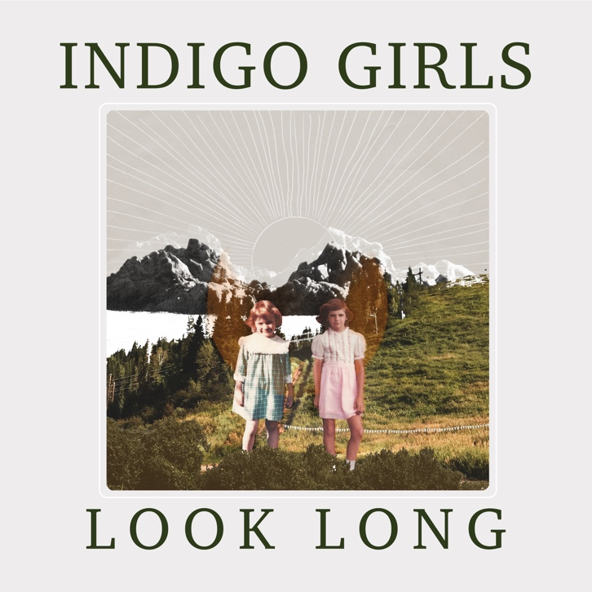

May 1, 2020 – Nashville, TN – Inspired by the response to their March 19 livestream––around 80,000 viewers—Indigo Girls have confirmed a concert and Q&A livestream series for every Thursday in May (7, 14, 21) at 7:00pm ET (Facebook Live and Instagram Live). The May 14 concert will include an optional donation with all proceeds to charity.

“We were amazed and honored to have so many folks tuning in the last time we did a livestream,” says Amy Ray. “Especially cool is the way the community comments to each other and gets super connected and engaged. We need that kind of connection in this world and we feel so lucky to have all y’all! So glad Emily and I can do this and have access to some internet :-).”

Indigo Girls are also sharing “Country Radio” from their upcoming album, Look Long (May 22, Rounder). Written by Saliers, the song had been added to the set on recent tours, including a full-band performance onLive from Here with Chris Thile. “I can tell it’s resonating with people,” says Emily. “When I get to that line, ‘I’m just a gay kid who loves country radio,’ there’s an audible verbal response from the audience.”

"This song is the way I felt doing those four-hour drives from Nashville to Atlanta, listening to country music radio,” Saliers remembers. “I could almost put my own life story in these songs, but I can’t. There are gender divisions and heteronormative realities. There’s a lot of self-homophobia that I’ve had to work on in my own life that plays into this as well.”

“Country Radio” is out now, alongside “Shit Kickin’,” “Change My Heart” and “When We Were Writers.”

Produced by John Reynolds at Peter Gabriel’s Real World studios in Bath, England, Look Long was born from a need for Saliers and Amy Ray to sing songs and bolster each other. “People can feel lost in these times,” Saliers explains. "Let’s lament our limitations, but let’s also look beyond what’s right in front of us, take the long view of things, and strive to do better.”

In 1999, Reynolds produced Indigo Girls’ beloved album, Come On Now Social, a time described by Ray as “one of the most important moments in our musical growth.”

The power of unity has always been an Indigo Girls calling card, and maybe because of it, they’ve been having a resurgence: Their audience has become more expansive and diverse, and they have a new generation of devoted peers, like Brandi Carlile and Justin Vernon, who recently said on the Broken Recordpodcast how he, “…adored them more and more—the more they had strength in the face of their adversity,” says Vernon. “They’re my favorite group ever.”

Since their 1989 self-titled, breakout album, the Grammy award-winning duo has racked up a slew of gold and platinum certifications and sold-out tours around the world, all while engaging in committed and uncompromising social and political activism, including immigration reform (El Refugio), LGBTQ rights, education (Dolly Parton’s Imagination Library), death penalty reform, and sustainability in Native communities. They are co-founders of Honor the Earth, a non-profit dedicated to Indigenous environmental justice and green energy solutions. They have granted over three million dollars to Native-led grassroots groups and campaigns fighting against bad energy projects but also funding sustainable ones.

Look Long tracklisting
Shit Kickin’
Look Long
Howl at the Moon
When We Were Writers
Change My Heart
KC Girl
Country Radio
Muster
Feel This Way Again
Favorite Flavor
Sorrow and Joy

www.indigogirls.com

